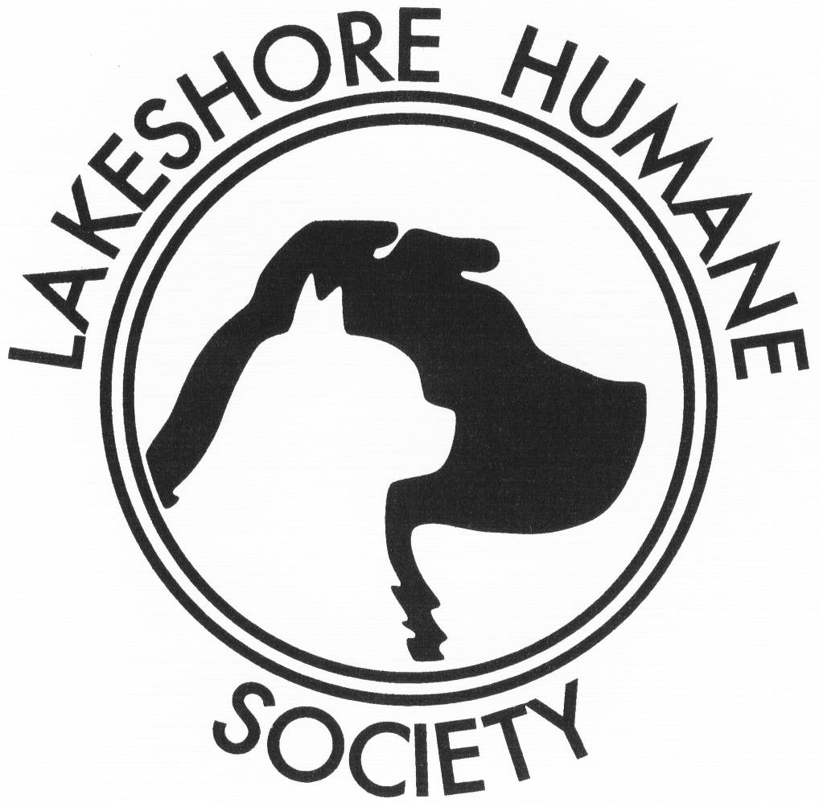
ATTENTION:
SNAP TREASURER

Lakeshore Humane Society Spay/Neuter Application
431 E. Chestnut Street, Dunkirk, NY 14048
(716) 672-1991 www.lakeshorehumanesociety.org

Please read and follow the Instruction Sheet on the back of this form to be able to receive assistance. This is not a rebate program. We will not supply funding if your animal has already been spayed or neutered. After reading the instruction sheet, please fill out the top section information below and return this completed form along with a stamped, self-addressed envelope to the address above: Attention: SNAP Treasurer.

To Be Filled Out By The Cat/Dog Owner PRIOR TO MAILING APPLICATION BACK TO LHS.
Do not take this form to your Veterinarian until you receive authorization.

Owner’s Name: __________________________________________ Telephone #: _________________
Street: ______________________________________________________________________________
City/State/Zip:________________________________________________________________________
Pet’s Name: ___________________________________________________ Cat Dog
Age _____Physical Description of Pet:______________________________ Female Male
Township to which you pay taxes: ________________________________________________________

To Be Filled Out By The Lakeshore Humane Society SNAP Treasurer
Authorization for Spay/Neuter Assistance

Voucher # ________________ Authorization Date: _______________ Expiration Date: _____________

The amount of $80 for female cats and dogs and $50 for male cats and dogs will be paid to the Veterinarian (Clinic/Veterinarian Hospital) after the completion of said surgery and the receipt of the signed and dated form.

Signature of LHS Program SNAP Treasurer:________________________________________________

To Be Filled Out By the Veterinarian
Please do not accept this form without the LHS SNAP Treasurer’s signature. Please do not accept the form after the expiration date.

Please sign, date and mail this entire form to LHS, 431 E. Chestnut Street, Dunkirk, NY 14048. ATTN: SNAP TREASURE. You will be promptly paid the above specified amount to assist the above cat/dog owner with the fee. The cat/dog owner is responsible for the remaining portion of the bill and Lakeshore Humane Society assumes no legal or financial responsibility beyond the quotation above.

The cat/dog _____________________ was Spayed Neutered by me on _____________(date).

Signature of Veterinarian: ______________________________________________________________

This certificate is not transferable and is void after date shown above. The Lakeshore Humane Society and its members assume no legal or financial responsibility beyond the quotation above. Due to limited funding, we are able to offer assistance only to the following townships and the cities and villages contained within: Arkwright, Brocton, Charlotte, Cassadaga, Chautauqua, Dunkirk, Forestville, Fredonia, Hanover, Irving, Mayville, Pomfret, Portland, Ripley, Sheridan, Silver Creek, Sinclairville, Stockton, Villenova, Westfield.

Lakeshore Humane Society Spay/Neuter Application
431 East Chestnut Street, Dunkirk, NY 104848
(716) 672-1991 www.lakeshorehumanesociety.org

How our program works (you will only receive assistance if these procedures are followed):

- Fill out and mail us a request for assistance. Please return this form along with a stamped, self-addressed envelope. You will receive your authorization form in approximately 1-2 weeks. If you have an emergency situation and feel that you cannot wait for the authorization, please call us at 716-672-1991 and someone will help you. Spay and neuter assistance is available only for the townships listed on the front of this application.

Note: Spay and neuter assistance is not a rebate program. If you have already had your pet spayed or neutered, you are not eligible for assistance.

- You will receive your authorized form from the SNAP Treasurer. On it will be the amount we will be able to fund for your pet’s surgery. Our funding ranges from $50-$80 depending on whether your animal is a cat or dog, male or female. Please take the authorized form with you on the day that your pet is spayed or neutered. Your vet will sign it at the time of the surgery. The funds will be paid directly to the Veterinarian (Clinic/Veterinary Hospital) who performs the surgery. Authorization will be given on a first-come-first-serve basis. The cat/dog owner is responsible for the remaining amount of the veterinary bill.

Veterinarians (Clinics/Animal Hospitals) who have agreed to participate in SNAP:

Veterinarian/Hospital/Clinic | Location | Phone Number
Chautauqua Veterinary Service | Stow | 716-789-3806
Concord Veterinary Center | Springville | 716-592-2588
Dunkirk Animal Clinic | Dunkirk | 716-366-7440
Falconer Veterinary Clinic | Falconer | 716-665-2077
Forestville Animal Clinic | Forestville | 716-965-1021
Fredonia Animal Hospital | Fredonia | 716-679-1561
Moonbrook Veterinary Hospital | Jamestown | 716-488-0788
Dr. Scott G. Nachbar | Springville | 716-592-7387
Randolph Veterinary Clinic | Randolph | 716-358-6817
Dr. W. H. Shaw | Randolph | 716-358-6902
Tri-County Vet Clinic | Clymer | 716-355-4234
Village Veterinary Hospital | Westfield | 716-326-8800
Westfield Animal Hospital | Westfield/Dunkirk | 716-326-3933

Funds are limited and are dependent on grants.
Funding provided by the Bertha Hamilton Trust Fund.

